**Is there a causal connection between power use and economic development, according to empirical research?**

The aim of this paper is to examine the empirical co-integration, long- and short-run dynamics, and causal link between Bangladesh's power consumption and real GDP. The analysis demonstrates the short-term unidirectional causal flow between per capita real GDP and per capita electricity consumption. The study's findings also provide compelling evidence of a long-term causal link between per capita real GDP and per capita power usage. And, looks at the existence and direction of a causal link in order to make wise policy choices about the usage of energy.

A Granger causality test based on the vector error-correction model (VECM) was used to examine the link; F- and t-tests were run to determine the joint significant levels of causality between GDP and electricity consumption. They preferred per-capita GDP and power usage statistics for Bangladesh. It is obvious that factors other than per capita power usage might have a remarkable impact on economic growth. Therefore, leaving such components out might affect both the estimation findings and the factors' causation. In order to prevent omitted variable bias and simultaneity bias in their regression, they included trade openness and government spending (GE), but in per capita form. They collected data on annual statistics on PCEC and PCGDP from world-bank for the years 1971 across 2014[1]. The model's functional form, which satisfies the study's main goal, is as follows:



Where PCEC denotes the amount of power consumed per person (in kWh). The PCGDP stands for per capita GDP (constant 2010 in US dollar). PCGE (per capita government final consumption expenditure) and TO (trade of) are both in constant 2010 US dollars.

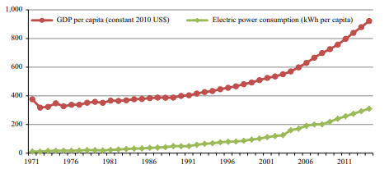

Once stationarity or cointegration is established, the econometric version of the aforementioned model linking to GDP and electricity consumption was delivered as follows: 

α is the intercept, β1−β3 are the coefficients of exogenous variables and ε is the error term , all the variables stated in the functional form above are present.

As a result, Strong evidence is being provided by both short-run and long-run coefficients that there is a significant positive relationship between electricity usage. The bi-directional long-run causation between GDP and electricity consumption is further supported by a combined F-test. The robustness of their long-run results was tested using three different estimators. Their findings of positive electricity consumption‒economic growth nexus remain robust to all these three estimators

In this way, their overall study results suggest that the feedback hypothesis, which states that there is a bidirectional causal relationship between electricity consumption and GDP, exists both in the short-run and the long-run, showing that as Bangladesh's economy expands, electricity demand rises and vice versa.

.